|  |  |  |  |
| --- | --- | --- | --- |
| Name:  Teacher : | ____________________________________  ______________________ | | Date:_________ |
|  | **Year 12 Essentials – Practical Application**  **Fitting Furniture in a Room**  **Conditions: 1 lesson in class and 1 week to take home.**  **Weighting 7% Due Date: ____________** | **Mark _________** | |

A well laid out room makes it easier to move around as well as feeling better to work in. This means making sure that there is adequate space to move around and that lines of sight are not blocked wherever possible.

James is building a new house. You will need to identify common items of furniture for a combined living/dining room, select appropriate items and create a floor plan showing two alternatives for fitting them into a room but still having space to move around.

You need to draw each item of furniture from the top using appropriate geometric conventions. Each living/dining room needs comfortable seating for five people, an appropriate entertainment unit, a coffee table, and a dining space for at least 4 people.

Using the plan on the below, come up with two possible arrangements that would work in the specified rooms. How much floor space is left once you have placed your items of furniture, ensuring that there is a pathway that is at least 80cm wide to get around.

You will need to write a report to show that you have applied the following steps in the mathematical thinking process:

• interpret the task and gather the key information

• identify the mathematics which could help to complete the task

• analyse information and data from a variety of sources

• apply their existing mathematical knowledge and strategies to obtain a solution

• verify the reasonableness of the solution

• communicate findings in a systematic and concise manner.

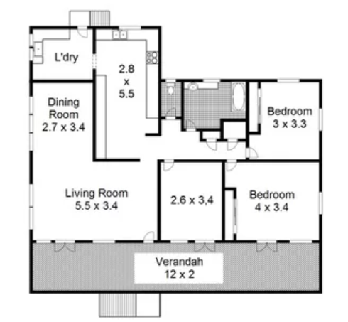

Name:___________________________________ Mark______/35

**Interpret the task and gather the key information**

|  |  |
| --- | --- |
| Introductory statement about what the report will cover | 2 marks |

**Identify the mathematics which could help to complete the task**

|  |  |
| --- | --- |
| Statement about the key information needed to complete the task   * 2 scaled furniture layout options * area of floor space used * ensure 80cm wide pathway * requirements (5 ppl living; 4ppl dining; area/dimensions of room; furniture requirements noted on task sheet) | 4 marks |

**Analyse information and data from a variety of sources**

|  |  |
| --- | --- |
| Reference within report body of how furniture was obtained | 1 mark |
| Reference section included | 1 mark |

**Apply their existing mathematical knowledge and strategies to obtain a solution**

|  |  |
| --- | --- |
| Report lists measurements/dimensions of furniture | 2 marks |
| Report outlines total area of furniture | 2 marks |
| Calculation of total remaining floor space | 2 marks |
| Report shows stepwise calculations of area of furniture | 2 marks |
| Furniture is represented on scale drawing with appropriate geometric convention | 2 marks |
| Furniture is represented on scale drawing correctly scaled | 2 marks |
| Two rooms are drawn to scale on scale drawing following plan on task sheet | 2 marks |
| Scale key noted | 1 mark |
| At least 80cm (drawn to scale) pathway in all two arrangements has been noted | 4 marks |

**Verify the reasonableness of the solution**

|  |  |
| --- | --- |
| Statement that summarises any difficulties in completing task | 1 mark |
| Statement about which arrangement is the better option giving reasons | 2 marks |

**Communicate findings in a systematic and concise manner.**

|  |  |
| --- | --- |
| Ruler used in completing scale drawings | 1 mark |
| Labels/key used to aid with reading of scaled drawings | 1 mark |
| Report set out in neat/logical format | 2 marks |
| Concluding statement | 1 mark |